**On Server:**

1. Install below IIS, .NET Framework roles

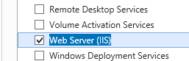

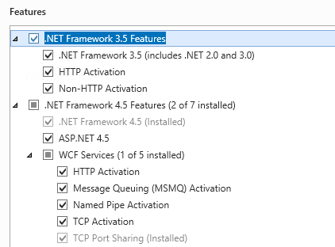

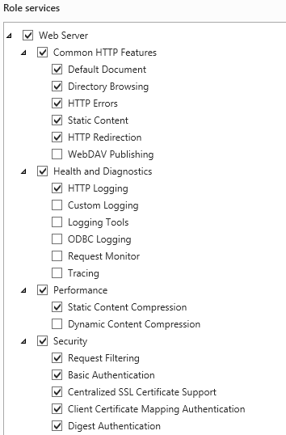

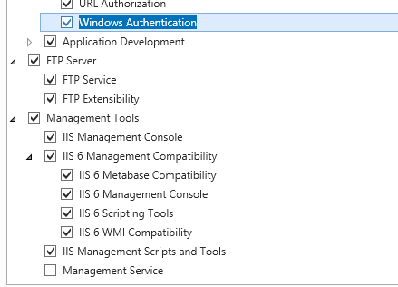

1. From IIS
   1. Remove HTTP bindings
   2. Bind Port 5002 for HTTPS
   3. Generate new IIS Self Signed Certificate and assign to HTTPS
   4. Rename default page in IIS Root directory

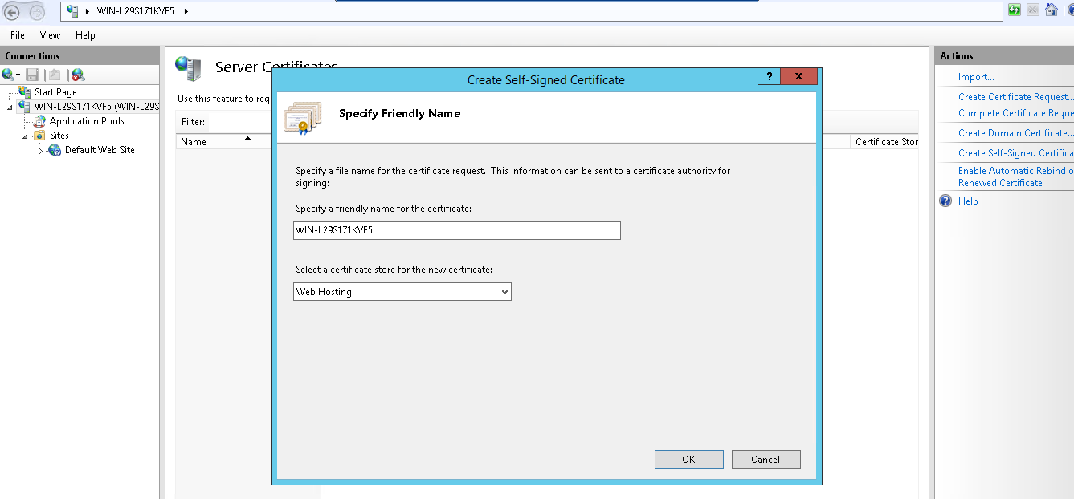

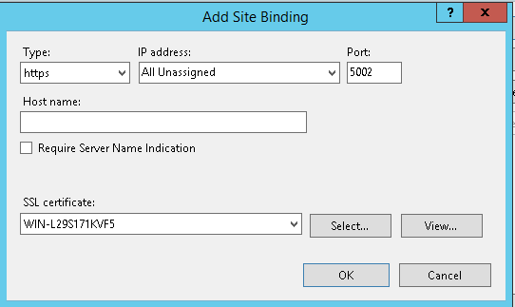

1. Install Myrtilee (Run as Admin, Enable **Run As Service** option) and configure

<https://github.com/cedrozor/myrtille/releases/download/v2.8.0/Myrtille_2.8.0_x86_x64_Setup.msi>

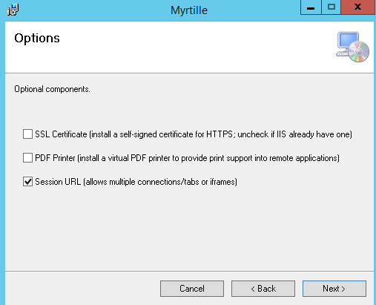

Tweak performance as per link: <https://github.com/cedrozor/myrtille/blob/master/DOCUMENTATION.md#configuration--performance-tweaks--debug>

Attached are the tweaked config files



*) Restart Website

*) Restart app pool

1. Enable WebRDP Port (eg: 5002), in Windows Firewall, Inbound rules

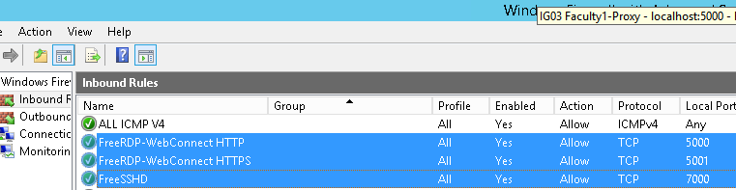

1. Note: Ensure you choose ports (eg: 5002) , which are opened in “Security Group”, associated with the VM’s (Server) in the cloud

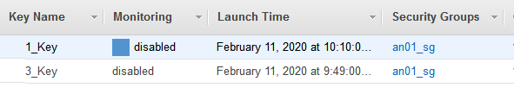

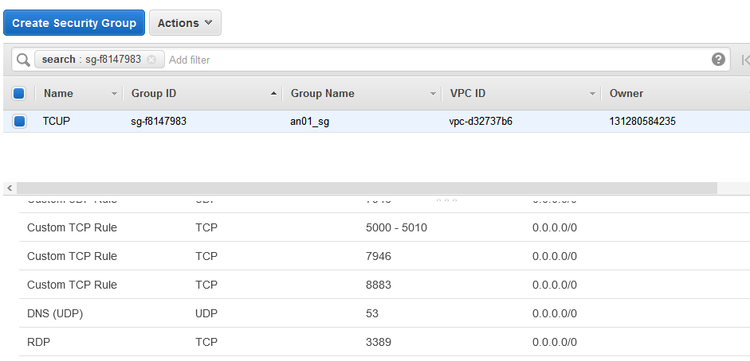

1. Have the below settings in GPEDIT. Msc

Local Computer Policy->Computer Configuration->Administrative Templates->Windows Components->Remote Desktop Services->Remote Desktop Session Host->Remote Session Environment

Limit Maximum Color Depth = 16

Enforce Removal of Remote Desktop Wallpaper=True



1. Set the Performance Options

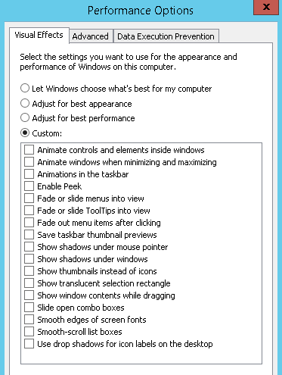

1. Reboot Server

**On Local Machine/VDI**:

1. Refer (Secure RDP WebConnect Manual Instructions.docx)